|  |  |  |
| --- | --- | --- |
|  | IMO-logo-rgb | ***E*** |

|  |  |
| --- | --- |
| FACILITATION COMMITTEE  46TH session  Agenda item xx | FAL 46/INFXX  21 February 2022  Original: ENGLISH  Pre-session public release: |

**Improve quality and availability of Nautical Data**

**Submitted by IHMA**

|  |  |
| --- | --- |
| **SUMMARY** | |
| *Executive summary:* | This document provides an introduction to the Guide for Nautical Data. The Guide for Nautical Data has been written to support Hydrographic Offices and Port Authorities to discharge their collective responsibilities as per SOLAS Chapter V, Regulation 9. |
| *Strategic Direction, if applicable:* |  |
| *Output:* |  |
| *Action to be taken:* | Paragraph 10 |
| *Related documents:* | Resolution MEPC 323(74); FAL 46/5/1; FAL.5/Circ.42/Rev.1 |

**Introduction**

1. Port call operations involve a substantial number of actors. Upon reaching the coastal area, the maritime authority is involved in the port call process. For example: when the ship enter the port the port authority needs to give its approval, or when a service provider deals with such things as waste and security; or an agent ensures that everything goes according to plan. And the same group of actors are needed to get the ship ready to depart from berth, leaving the port area, and back to the open sea.
2. A description of a high-level port call business process has been explained in a recent submission to the FAL Committee, FAL 46/5/1, in which it is described how the nautical, administrative, and operational data, forms part of the maritime data single window exchange.
3. The guide on how to setting up a maritime single window, FAL.5/Circ.42/Rev.1, describes the exchange of in particular administrative data.
4. A similar guide related to operational data is under development by the Correspondence Group on Developing Guidelines on Electronic Signature Systems and Operational Port Data for the purpose of digital information exchange.
5. In the annex to this submission is a Guide for Nautical Data: data that are provided by coastal administrations, usually through hydrographic offices, ensuring safe navigation.
6. The annexed Guide provides information to Harbour Masters on how to share data about the port:
7. Port infrastructure in Nautical Charts and Nautical publications
8. Port depths in unofficial Nautical Charts
9. Port information in unofficial Nautical Publications
10. The content is based on basics first:
11. To allow ships to be compliant with IMO Resolution A.893(21): berth to berth navigation
12. To allow ports to be compliant with IMO Resolution A862(20): recommended contents in port information books
13. To be aligned with the standards of the International Hydrographic Organization
14. Both the Guide on Navigational Data and the Guidelines on Operational Port Data (under development by the Correspondence Group) follow up on the actions set out in MEPC.323(74):

.1 Paragraph 2.4: *“...supporting the industry’s collective efforts to improve quality and availability of data and develop necessary global digital data standards that would allow reliable and efficient data exchange between ship and shore thereby optimizing voyages and ports calls…”*

**Action requested of the Committee**

1. The Committee is invited to note the information contained in this document.

***

**ANNEX**

**GUIDE**

**for**

**NAUTICAL DATA ©**

Version 1.0

 ©



Content

List of abbreviations 4

Foreword 5

1.1 Nautical data as part of the port call process 6

1.2 Nautical data use cases 7

1.3 Challenges Hydrographic Offices 8

1.4 Challenges Port Authorities 8

2.1 Nautical Charts 9

2.2 Nautical publications 10

2.3 Roadmap 11

3.1 Port infrastructure in Nautical Charts and Nautical publications 12

3.2 Port depths in unofficial Nautical Charts 17

3.3 Port information in unofficial Nautical publications 18

4.1 Appendix for tide information template 25

**Document Revision history**

|  |  |  |
| --- | --- | --- |
|  |  |  |
|  |  |  |
|  |  |  |
|  |  |  |
|  |  |  |
|  |  |  |
|  |  |  |
|  |  |  |
|  |  |  |
|  |  |  |
|  |  |  |
|  |  |  |
|  |  |  |
|  |  |  |

**Copyright Notice**

All rights reserved. Permission to print or save the document or excerpts of it is only granted for

private, non-commercial use, without any right to resell or redistribute them or to compile or create derivative works therefrom. Any copyrights within the document remains with the original rights holder. Enquiries should be directed to [Scherpenzeel.ehmc@portmaster.org](mailto:Scherpenzeel.ehmc@harbourmaster.org)

Please cite this document as: Port Information Manual for Nautical Data of BIMCO, IAPH, IHMA, IHO, ITPCO

# List of abbreviations

|  |  |
| --- | --- |
| AVANTI | Access to Validated Nautical Information |
| BIMCO | Is the world’s largest direct-membership organisation for shipowners, charterers, shipbrokers and agents |
| ECDIS | Electronic Chart Display Information System |
| ENC | Electronic Navigational Chart |
| FAL | Convention Facilitation of International Maritime Traffic |
| HO | Hydrographic Office |
| IAPH | International Association of Ports and Harbours |
| IHMA | International Harbour Master Association |
| IHO | International Hydrographic Organization |
| IMO | International Maritime Organization |
| ITPCO | International Taskforce Port Call Optimization |
| LMIU | Lloyds Marine Intelligence Unit |
| NW | Navigational Warning |
| RENC | Regional Electronic Navigational Chart Coordination Center |
| SD | Sailing Direction |
| UKHO | United Kingdom Hydrographic Office |
| VAR | Value Added Resellers |

# Foreword

Dear Reader,

The Guide for Nautical Data has been written to demonstrate that Hydrographic Offices and Port Authorities have worked together to discharge their collective SOLAS responsibilities as per Chapter V Regulation 9.

The content is based on:

* Use cases with most impact on IMO objectives: safety, environment, security:
* Port infrastructure in Nautical Charts
* Port depths in Nautical Charts
* Port information in Nautical publications
* Being compliant with IMO
* Resolution A.893(21): berth to berth navigation
* Resolution A862(20): recommended contents in port information books

The standards are based on:

* IHO standards
* UKHO / IHMA document, if IHO standards were not available
* IHO NIPWG comments on Port Information Manual

If ports and/or port users feel that the content or standards need an update to reflect current operations, changes will be proposed to IMO and/or IHO.

Ben van Scherpenzeel

Project Officer International Port Master Association for Nautical Port Information

Chairman International Taskforce Port Call Optimization

# 1.1 Nautical data as part of the port call process

The port call process is based on high-level business process of port calls, which is based on IMO regulations, BIMCO contracts, requirements of port authorities and other stakeholders, making it a port and trade agnostic process. It has been created by the Industry (a group of leading ports and shipping lines) and validated during Industry Roundtable sessions organized by the IMO Global Industry Alliance (GIA) to Support Low Carbon Shipping.

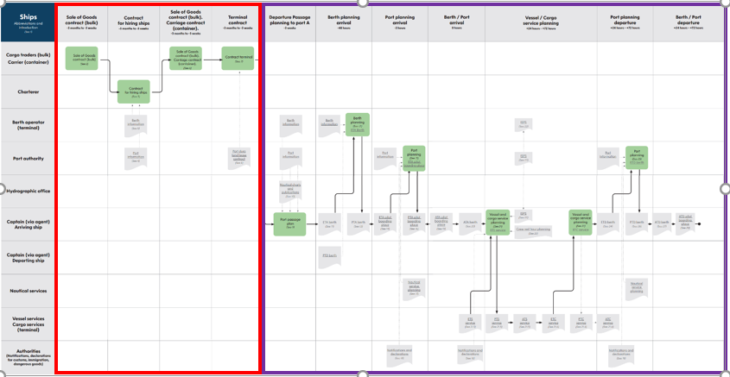

From left to right:

**Contractual phase:**

* Sale of goods contract (bulk sector)
* Contract for chartering ships
* Sale of goods contract (bulk sector), carriage contract (container sector)
* Terminal contract

**Operational phase:**

* Passage planning
* Berth planning arrival
* Port planning arrival
* Berth / Port arrival
* Vessel service planning
* Port planning departure
* Berth/ Port departure

Data to be exchanged:

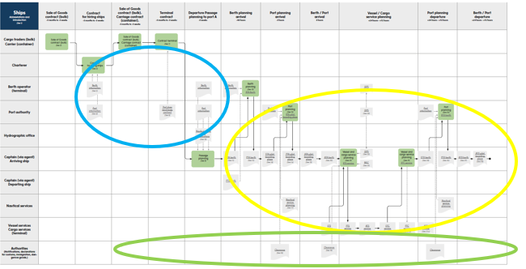

The port call data sets are:

* Nautical data: data that is provided by Hydrographic Offices in navigational charts, nautical publications or coast pilots, and tide tables.
* Administrative data: data that is submitted by ships or other non-authority parties to authorities in notifications and declarations.
* Operational data: data that is submitted to non-authority parties as part of planning or execution of certain operations.

# 1.2 Nautical data use cases

* Port Infrastructure in Nautical Charts: Masters are obliged to navigate berth to berth by using official Nautical Charts and Nautical publications to fulfil SOLAS carriage requirements. This is however a challenging undertaking if the terminal, berth or berth position is not displayed in the nautical chart, or if the information differs between e.g., the Nautical Chart and the Sailing Direction. Shipping lines have requested to improve quality and availability of nautical port information.
* Port depths in Nautical Charts: Masters have difficulties to optimize the deadweight of the vessel and apply a safe Under Keel Clearance if local depths are different from Nautical Chart or if the Under Keel Clearance definitions are different.
* Port information in Nautical publications: voyage planning is difficult if local Port Information Books are different from Nautical publications.

# 1.3 Challenges Hydrographic Offices

* Official Nautical Charts and Nautical publications are issued by or on the authority of a Government authorized Hydrographic Office (HO) or other relevant government institution. Most HO’s act in accordance with the IHO recommendation to distribute ENC’s through a controlled process of validation and distribution through RENC and VAR’s. Taking also into account an external dependency on the update mechanism on board, today the time between actual measurement or sounding and chart update on board may typically be about 4 weeks.
* Hydrographic Offices of the IHO Nautical Information Provision Work Group experience a lack of data availability and consistency of port authorities, resulting hydrographic offices being unwilling to publish port infrastructure data in their charts and publications as they cannot guarantee the correctness of the data.
* If ports share their latest soundings, the amount of data may be too much for the Hydrographic Office to handle.

# 1.4 Challenges Port Authorities

* Ports publish unofficial Nautical Charts and Nautical publications to share data that changes more frequently than the update frequency of official Nautical Charts and Nautical publications (e.g., updates of soundings if ports are affected by siltation).
* Ports face difficulties to gather data from all data owners in the port, as the port authority is not data owner of all port data (e.g., terminals may be the data owner of the soundings of the berthing pocket).

# 2.1 Nautical Charts

#### Introduction

Nautical Charts are special purpose maps specifically designed to meet the requirements of marine navigation, showing amongst others depths, nature of bottom, elevations, configuration and characteristics of coast, dangers and aids to navigation. Nautical Charts offer a graphical representation of relevant information to mariners for planning and executing safe navigation.

There are two types of official Nautical Charts:

* Paper chart – still used as back up of the electronic charts
* Electronic navigational chart (ENC), with comparable content to the official paper chart, current standard is S-57, used in the Electronic Chart Display Information System (ECDIS). A special form of an ENC is the high-density bathymetry (HD ENC). A special ENC with more bathymetric content compared to ENC.

#### Official Nautical Charts

Are issued by or on the authority of a Government authorized Hydrographic Office or other relevant government institution. Most HO’s act in accordance with the IHO recommendation to distribute ENC’s through a controlled process of validation and distribution through RENC and VAR’s. Taking also into account an external dependency on the update mechanism on board, today the time between actual measurement or sounding and chart update on board may typically be about 4 weeks.

#### Unofficial Nautical Charts

May be issued locally by ports, to share data that changes more frequently than the update frequency of official Nautical Charts (e.g., updates of soundings if ports are affected by siltation).

#### Use on board of official and unofficial Nautical Charts

Only official Nautical Charts fulfill SOLAS carriage requirements, unofficial Nautical Charts don’t. Therefore, ships must use the official ones, and pilots can use the unofficial ones. Navigating a vessel with the Bridge Team whereby one part of the team uses different information than the other part of the Bridge Team is not the ideal situation. Both parties should have chart information which has the same source and the same time stamp.

#### Solution

Ports and Hydrographic Offices work together to share their latest information using the same standards for better alignment of official and unofficial Nautical Charts, and allowing future real time data exchange and eliminating the need for unofficial Nautical Charts altogether.

# 2.2 Nautical publications

#### Introduction

Nautical publications provide additional information related to Nautical Charts in a particular area. Both are building an information entity and must be carried by every SOLAS vessel.

#### Official Nautical publications

They’re issued officially by. or on the authority of a Government authorized Hydrographic Office or other relevant government institution.

Update frequency purely depends on the availability of update information and therefore is variable.

#### Unofficial Nautical publications

May be issued locally by ports, to share data that changes more frequently than the update frequency of official Nautical publications (e.g., updates of details of port administration or arrival information requirements). For that reason, such data is often shared through unofficial Nautical publications (also called Port Information Books or Port Information Guides) for quick updates. May also be published by other publishers to provide details about port infrastructure as it’s not available in official Nautical Charts and/or Nautical publications, who again send questionnaires to ports to collect nautical data.

#### Use on board of official and unofficial Nautical Charts

Only official Nautical publications fulfill SOLAS carriage requirements, unofficial Nautical publications don’t.

However, the information differs between official Nautical publications and unofficial Nautical publications from Port Authority or other publishers, making it difficult to select the most reliable source.

#### Solution

Ports and Hydrographic Offices work together to share their latest information using the same standards for better alignment of official and unofficial Nautical publications, and allowing future real time data exchange and eliminating the need for unofficial Nautical publications.

# 2.3 Roadmap

The challenge of the coming years for nautical port information is that we’ve a mixed environment, with different needs and interests from users, publishers, and regulating bodies.

Identified phases:

|  |  |  |  |  |
| --- | --- | --- | --- | --- |
| Phase | Official  Nautical charts | Unofficial  Nautical charts | Official  Nautical publications | Unofficial  Nautical publications |
| 1 | Paper | Local format | Paper | Local format |
| 2 | Paper  ENC S-57 | Conversion to IHO format | Paper | Conversion to IHO format |
| 3 | Paper  ENC S-57  ENC S-100 | IHO format  S-100 exchange | Paper  S-131 | IHO format  S-131 exchange |
| 4 | ENC S-100 | S-100 exchange | S-131 | S-131 exchange |

Today we’re in phase 2.

This manual provides guidelines to transfer local formats of unofficial Nautical Charts and Nautical publications into IHO formats.

This will help ports to be prepared for phase 3 and 4, as alignment with IHO standards is a first requirement for future real time electronic exchange.

# 3.1 Port infrastructure in unofficial Nautical Charts and Nautical publications

***Port***

*Definition*

Any port, terminal, offshore terminal, ship and repair yard or roadstead which is normally used for the loading, unloading, repair and anchoring of ships, or any other place at which a ship can call.

The word “port” also embraces geographically, a city or borough which serves shipping interests.

Other national standards and frameworks may describe such administrative entities already (IHO S‑32).

*Location*

A single position or delimited area which represents the port as a whole. Generally, for a single position, a centre of gravity position is chosen to represent the port’s location. This is aligned with the airline industry.

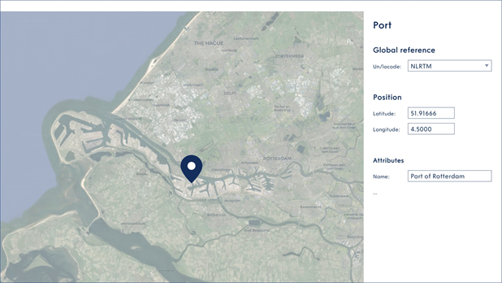

*Indirect reference for computer exchange*

* Global Location Number (GLN) (ISO/IEC 6523). E.g.: 9521234567882 for Port of Rotterdam

*Indirect reference for human exchange*

* UN/LOCODE; E.g.: NLRTM for Port of Rotterdam

*Direct reference for navigation*

* Decimal degrees to a defined precision, (minus to indicate South and West). Datum: WGS 84. E.g.: 51.9166666, 4.5000000 for Port of Rotterdam

*Other references*

* Name of port

***Port Section***

*Definition*

Ports can have multiple different types of sections. The most common ones are:

* Anchorage: An area in which vessels anchor or may anchor (NP100)
* Fairway: The main navigable channel in the approaches to, or within, a river or harbour. Sometimes called the Ship Channel (NP100)
* Turning basin: An area of water or enlargement of a channel in a port, where vessels are enabled to turn, and which is kept clear of obstructions such as buoys for that purpose (NP100)
* Basin: A sheltered body of water available for port operations connecting either with the sea, with an outer port or with another basin. Generally, an almost land locked area leading off an in inlet, firth, or sound. Also, an area of water limited in extent and nearly enclosed by structures alongside which vessels can lie (IHO S-32)

*Location*

A single position or delimited area which represents the port section as a whole. Generally, for a single position, a centre of gravity position is chosen to represent the port section

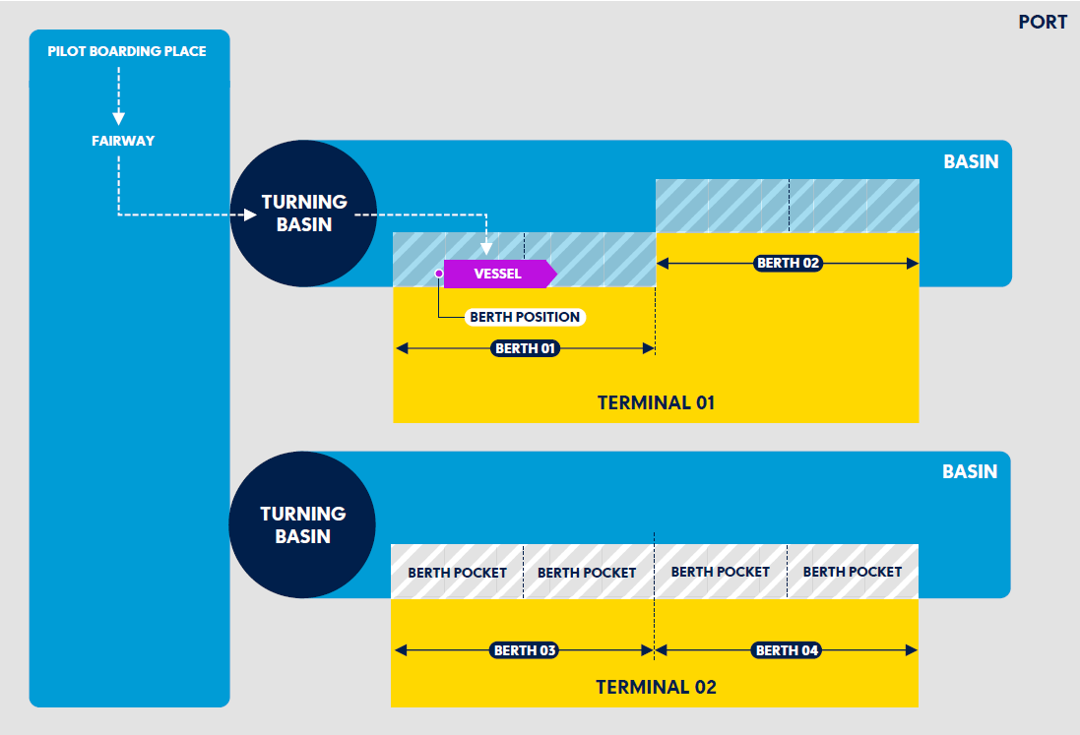

*Indirect reference for computer exchange*

* Global Location Number (GLN) (ISO/IEC 6523)

*Indirect reference for human exchange*

* Port Section Code: Alphanumeric, maximum 4 characters. E.g.: WAAL for Waalhaven

*Direct reference*

* Decimal degrees to a defined precision, (minus to indicate South and West). Datum: WGS 84 E.g.: 51.92000000, 4.5000000 for Waalhaven

*Other references*

* Name of the port section

***Terminal***

*Definition*

A number of berths grouped together, providing facilities for handling a particular form of cargo, e.g., oil terminal, container terminal (IHO S-32)

*Location*

A polygon or single position which represents the terminal or berth operator as a whole. Generally, for single position cases, a centre of gravity is chosen to represent the terminal’s location.

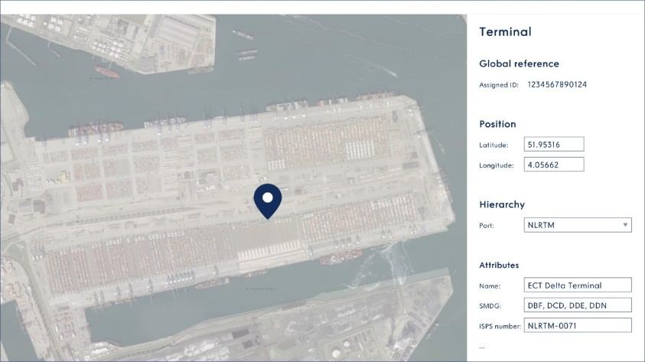

9521234567875

*Indirect reference for computer exchange*

* Global Location Number (GLN) (ISO/IEC 6523); 13 digits in text format. E.g.: 9521234567875 for the ECT Delta terminal shown in above illustration.

*Indirect reference for human exchange*

* UN/LOCODE + SMDG Code: Alphanumeric between 3 and 6 character. E.g.: NLRTM + OODDN or
* Terminal Code: Alphanumeric, between 3 and 6 character. E.g.: NLRTM + VOPAK

*Direct reference for navigation*

* In decimal degrees to a defined precision, (minus to indicate South and West). Datum WGS 84. E.g.: 51.887190, 4.284030

*Other references*

* Name of the terminal (call name, e.g., not the name of the mother company)
* IMO Port Facility (ISPS) Number; UN/LOCODE and a 4-digit code separated with a dash

***Berth***

*Definition*

The space assigned to or taken up by a ship when anchored or when lying alongside a quay, wharf, jetty, or other structure (IMO Data reference model IMO0232)

*Location*

When a ship is lying alongside e.g., a quay, wharf, jetty or other structure the berth’s extent is between its two extremities as shown in the diagram below, measured in a straight line, indicated by A and B, orientation is not important. The line represents the fender line, being the position of the ship’s side when alongside. When a ship is lying in e.g., a multiple buoy mooring the berth is represented by its mooring buoys, resulting in a polygon.

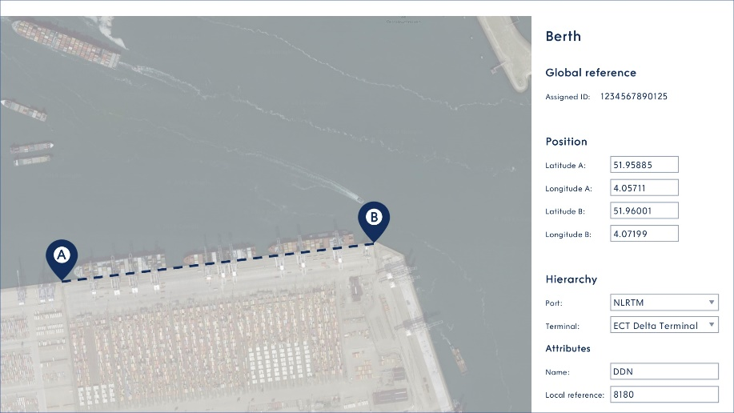

9521234567868

*Indirect reference for computer exchange*

* Global Location Number (GLN) (ISO/IEC 6523); 13 digits in text format. E.g.: 9521234567868 for the berth shown in the above illustration.

*Indirect reference for human exchange*

* UN/LOCODE + SMDG + Berth Code: Alphanumeric, between 6 and 9 characters. E.g.: NLRTM OODDN or:
* UN/LOCODE + Terminal Code: Alphanumeric, between 6 and 9 characters. E.g.: NLRTM VOPAKVP9

*Direct reference for navigation*

* In decimal degrees to a defined precision, (minus to indicate South and West). Datum WGS 84.E.g.: 51.887190, 4.284030 for positions A and B

*Other references*

* Name of berth, possibly combined with name of terminal name for better human recognition

***Berth position***

*Definition*

The position along the line of a berth, specified by one point (e.g., bollard, manifold or ramp number), allowing the ship to berth in the correct position along the berth (IMO Data reference model IMO0233)

*Location*

A single point. In decimal degrees to a defined precision, (minus to indicate South and West). Datum WGS 84.

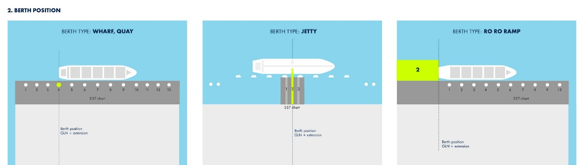

*Indirect reference for computer exchange*

* Global Location Number (GLN) (ISO/IEC 6523); 13 digits in text format plus extension. E.g.: 9521234567868-25.5 for the berth shown in the above illustration.

*Indirect reference for human exchange*

* UN/LOCODE + SMDG Code + Berth Code + extension. E.g.: NLRTM OODDN – 25.5 or:
* UN/LOCODE + Terminal Code + extension. E.g.: NLRTM VOPAKVP9 - 3

*Direct reference for navigation*

* In decimal degrees to a defined precision, (minus to indicate South and West). Datum WGS 84. E.g.: 51.887190, 4.284030

*Other references*

* Name of berth + bollard/manifold/ramp number

# 3.2 Port depths in unofficial Nautical Charts

#### Legal disclaimer

Any additional legal disclaimers that a port wish to make.

Advised is a so called “Notice of Intended Use”, e.g.,

“Only maintained depths should be used for passage planning of vessels and cargoes. Soundings should be used only after consultation with the port authority as they are affected by siltation and dredging operations. Responsibility for safe navigation remains with the master of the vessel. At any time, the port accessibility can be affected by unexpected causes such as  a localized movement of sediment or less water due to extreme weather factors or river flow”

#### Chart Datum

Chart Datum should be the same as the official Nautical Chart. The Hydrographic Office should be contacted if local Chart Datums need to be translated into international Chart Datums as used in the official Nautical Chart. This may be a time-consuming effort, as the grid in the port is more refined than the grid used by the Hydrographic Office at sea

#### Measurements

Measurements according IHO S-44 standards. If depths are not measured in line with S-44, the data cannot be used for publication by the Hydrographic Office.

#### Example of unofficial Nautical Chart

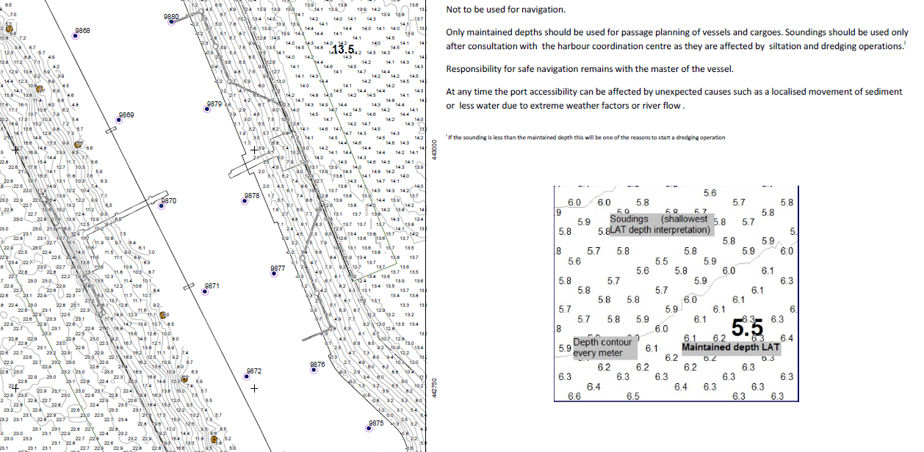

# 3.3 Port information in unofficial Nautical publications

#### Legal disclaimer

Any additional legal disclaimers that a port wish to make. Advised is a so called “Notice of Intended Use”, e.g., “Port of XXXX makes every effort to make and maintain the contents of this document as up-to-date, accessible, error-free and complete as possible, but the correctness and completeness of these contents cannot be guaranteed. Port of XXXX accepts no liability whatsoever for the occurrence and/or consequences of errors, faults or incompleteness or any other omission in connection with the information provided by this document. In case of any discrepancies or inconsistencies between this document and the applicable legislation, including the port bye-laws, the latter will prevail”

#### 1 Location of the port and the terminal

##### Location of the port

Please see chapter 3.1

##### Location of the terminal

Please see chapter 3.1

#### 2 Details of port administration

##### Port Authority Contact Working hours

Periodic working days and hours for the Port Authority when they are contactable. There may be multiple entries to specify the working hours completely. It does not define the specific working times of various port services or terminals: These should be recorded as individual services.

Format:

* Start: day and time: ISO8601. Day is one of Monday-Sunday
* End: day and time: ISO8601. Day is one of Monday-Sunday
* Week Day Start: Enumeration: Day is one of Monday-Sunday
* Week Day End: Enumeration: Day is one of Monday-Sunday

##### Contact Details

Detailed contact information for an official point of contact within the port.

Format:

* Contact
  + Individual Name [text]
  + Department / Administrative division [text]
  + Role [text]
  + Contact Instructions [text]
* Contact Details – Preferred
  + Service Type Radio, Voice, Fax, Email, Online: Enumeration
  + Number [text]
  + Address (online or email) [text]
  + Radio Frequency [text]
  + Call Name / Call Sign [text]
  + Service Working Hours (described in in Service Hours)
* Contact Details – Alternate (Optional)
  + Service Type Radio, Voice, Fax, Email, Online: Enumeration
  + Number [text]
  + Address (online or email) [text]
  + Radio Frequency [text]
  + Call Name / Call Sign [text]
  + Service Working Hours (in Service Hours)
* Address (1 per contact)
  + Delivery Point / Administrative Area [text]
  + City [text]
  + Postal Code [text]

##### Regulations

Details of any local regulations that apply in the port or its surrounding waters.

Format:

* Identifier: Free text
* Relevant Authority: Free text
* Regulation: Free text or reference to a port website
* Exemptions which may apply including contact details: Free Text.
* Supplementary information : Free Text.

#### 3 Radio communication procedures and frequencies

Specification of a communication channel for vessels in the port or a port section.

Format:

* VHF usage: Free text
* VHF channel(s): Free text
* Information: Free text

#### 4 Arrival information requirements

Detailed requirements for each report that needs to be sent to the port before arrival.

Format:

* Identifying name of Report: Free Text
* Date Issued: Date – ISO8601 format
* “Reporting party” – Who needs to send report
* Contact Details of recipient
* “How” – How report is to be sent: Free Text
* “When” – When report is required: Date – ISO8601 format
* “What” – Report requirements Text: Free Text
* Supplementary Information: Free text

#### 5 Port health, immigration, quarantine and customs regulations and procedures

Format:

* Free text

#### 6 Relevant charts and nautical publications

Charts and Navigational Publications such as Tide Tables that can be used to navigate the port approaches and port basins and waterways. A Nautical Chart or nautical publication is a special-purpose map or book, or a specially compiled database from which such a map or book is derived, that is issued officially by or on the authority of a Government, authorized Hydrographic Office or other relevant government institution and is designed to meet the requirements of marine navigation (SOLAS V/2 1974).

Format (per chart or publication):

* Chart number: Free text: (Chart only)
* Identifier: Free text (chart number or publication number)
* Title: Free text
* Producer: Free text

#### 7 Pilotage requirements

Format:

* Supply service type: Free text
* Service name: Free text
* Service location description: Free text
* Service area description: Free text
* Start: day and time: day = Monday-Sunday time=ISO8601
* End: day and time: day = Monday – Sunday time=ISO8601

#### 8 Towage and tug assistance

Format:

* Supply service type: Free text
* Service name: Free text
* Service location description: Free text
* Service area description: Free text
* Start: day and time: day = Monday-Sunday time=ISO8601
* End: day and time: day = Monday – Sunday time=ISO8601

#### 9 Berthing and anchorage facilities

##### Berthing facilities

Please see chapter 3.1

##### Anchorage facilities

Please see chapter 3.1 under “Port Sections”

#### 10 Port emergency procedures

##### Emergency coordination centre

The Emergency Coordination Centre information for the port. Individuals should be entered as a “Point of Contact” and referenced within this information.

Format:

* Free text

##### Emergency response equipment

Types, locations and availability of emergency response equipment.

Format:

* Equipment type: Free text
* Equipment availability: Free text

##### Emergency procedures

Relevant emergency response procedures.

Format:

* Category of emergency: Free text
* Emergency procedure: Free text

#### 11 Significant weather features

Details of any important local weather conditions within the port.

Format:

* Phenomena: Free text
* Details: Free text
* Location: Free text
* Expected period start: MM
* Expected period end: MM
* Reference to a port website

#### 12 Availability of fresh water, provisions, bunkers and lubricants

Format:

* Supply service type: Free text
* Service name: Free text
* Service location description: Free text
* Service area description: Free text
* Start: day and time: day = Monday-Sunday time=ISO8601
* End: day and time: day = Monday – Sunday time=ISO8601

#### 13 The maximum size of ship the port can accept

Any size constraints on vessels using the port as a whole. It is not intended to capture constraints that may exist within an individual berth or port section as each section may have its own limits such as channel widths, swinging areas dimensions etc – these should be captured in the appropriate section.

Format:

* Maximum allowed overall length of a vessel: in decimal meters, resolution .0.01m
* Maximum beam: in decimal meters, resolution .0.01m

#### 14 Maximum permissible draught and minimum depth of water in navigation channels

##### Maximum permissible draught in navigation channels

Maximum draught without over the tide operations: maximum draught without utilizing tidal operations.

Maximum draught with over the tide operations: maximum draught utilising tidal changes to discharge or load cargo before a low tide level is reached, thus maintain the vessel “always afloat”.

Format:

* Decimal metres, to a defined water density measured in kg/m3

##### Minimum depth of water in navigation channels

The minimum (shoaliest) value of a depth range.

Format:

* Decimal metres with reference to a specific Sounding Datum
* Chart Datum to be aligned with official Nautical Charts

#### 15 Water density at the port

Density is equivalent to specific gravity and represents the ratio, at atmospheric pressure, of the weight of a given volume of sea water to that of an equal volume of distilled water at 4 degrees Celsius.

Format:

* Kg/m3

#### 16 Maximum permissible air draught

Maximum (air) draught (height of the highest point of the vessel above the waterline).

Format:

* Decimal meters, resolution .0.01m

#### 17 Requirements for ship’s draught and trim for navigation in the waterways

Restrictions or conditions on the ship’s draught and trim

Format:

* Free text

#### 18 Tidal and current information

Any official tidal information provided by the port.

Format:

* Same standards as in the official Nautical Chart for reference stations, Chart Datum, time, units of measurement
* Reference to a port website

If port website is used, please see also appendix 4.1 for a light pdf version which can be sent to the vessel.

#### 19 Restrictions or conditions on the discharge of ballast water

##### Ballast water discharge restrictions or conditions

Restrictions or conditions on the discharge of ballast water

Format:

* Free text

#### 20 Statutory requirements regarding loading and cargo declaration

Format:

* Free text

#### 21 Information on waste reception facilities in the port

Restrictions or conditions on the discharge of waste

Format:

* Free text